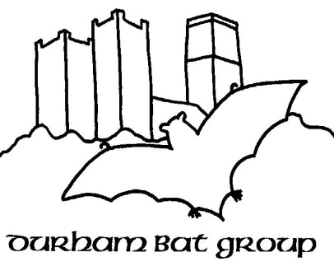
Durham Bat Group - Annual Membership Form
Membership runs from April 2016 – March 2017 inclusive
Durham Bat Group’s Objects are
- To promote the conservation and welfare of bats
- To work within the geographic area covered by Durham Bat Group, that is primarily the area bounded by the Rivers Tees and Tyne, in providing practical advice and help to any individual or organisation with regard to bats
- To educate the public about bats by means of public talks, bat walks, talks to school groups etc., and to encourage community participation in bat related activities
- To study bats in order to further understanding of their biology and ecology
- To work with other organisations sharing similar aims

Contact Details
Name

Address

Phone (home / mobile)
Email

Please note email is the main way we send information and communicate as a group.
Other Information
Do you hold any licences for bat work | YES / NO | If yes, please specify:  .
Have you had rabies vaccinations / boosters | YES / NO

☐Please check the box if you are willing to allow your contact details to be shared with the Bat Conservation Trust
As a member of Durham Bat Group, I agree to further the objects of the group in good faith and to abide by the constitution of the group.
Signed :
Date:
If you are a new member, please give brief details about why you want to join the group and any relevant experience to date:

Please return completed forms to enquiries@durhambats.co.uk

